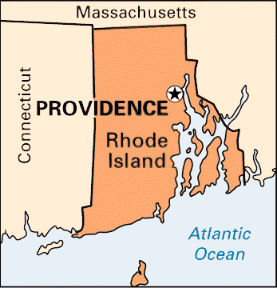
Providence is the capital of and most populous city in the U.S. state of Rhode Island, founded in 1636, and one of the oldest cities in the United States.^{[6]} It is located in Providence County and is the third most populous city in New England, after Boston and Worcester. Providence has a city population of 179,154; it is also part of the Providence metropolitan area which extends into southern Massachusetts. The Providence metropolitan area has an estimated population of 1,604,291, which exceeds that of Rhode Island as a whole by about 60%.^{[7]} This can be considered, in turn, to be part of the Greater Boston commuting area, which contains 7.6 million people.
Providence was founded by Roger Williams, a religious exile from the Massachusetts Bay Colony. He named the area in honor of "God's merciful Providence", which he believed was responsible for revealing such a haven for him and his followers to settle. The city is situated at the mouth of the Providence River at the head of Narragansett Bay.
The city was once nicknamed the "Beehive of Industry"; it began rebranding itself as the "Creative Capital" in 2009 to emphasize its educational resources and arts community.^{[8]}
By the early 1900s, Providence was one of the wealthiest cities in the United States.^{[14]} Immigrant labor powered one of the nation's largest industrial manufacturing centers.^{[14]} Providence was a major manufacturer of industrial products from steam engines to precision tools to silverware, screws, and textiles. Giant companies such as Brown & Sharpe, the Corliss Steam Engine Company, Babcock & Wilcox, the Grinnell Corporation, the Gorham Manufacturing Company, Nicholson File, and the Fruit of the Loom textile company were based in or near Providence.^{[14]}
From 1975 until 1982, $606 million of local and national Community Development funds were invested throughout the city. In the 1990s, the city pushed for revitalization, ultimately resulting in uncovering the rivers (which had been covered by paved bridges), relocating a large section of railroad underground, creating Waterplace Park and river walks along the river's banks, and constructing the Fleet Skating Rink (now the Alex and Ani City Center^{[15]}) downtown and the 1.4 million ft² Providence Place Mall.^{[9]}
In the 21st century, despite new investment, poverty remains an entrenched problem as it does in most post-industrial New England cities. Approximately 27.9 percent of the city population is living below the poverty line.^{[16]} Recent increases in real estate values further exacerbate problems for those at marginal income levels, as Providence had the highest rise in median housing price of any city in the United States from 2004 to 2005.^{[17]}

Want more? https://en.wikipedia.org/wiki/Providence,_Rhode_Island

