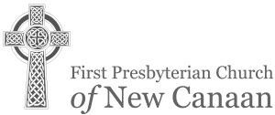

6TH SUNDAY OF EASTER CONFIRMATION SUNDAY MAY 21, 2017
- ALL WHO ARE ABLE ARE INVITED TO STAND.

GATHERING
O God, make the door of this house wide enough to receive all who need human love and fellowship, narrow enough to shut out all envy, pride, and strife. Make its threshold smooth enough to be no stumbling block to children, nor to straying feet, but rugged and strong enough to turn back the tempter’s power. God, make the door of this house the gateway to Thine eternal kingdom. Amen. --The Gathering at St. Stephen’s Wolbrook, England
- All who are able are invited to stand.
PRELUDE “Selections from Intabolatura Nova (1551)” Anonymous

* LITANY FOR CONFIRMATION Rev. Kathryn Kibbie Laird Minister: The journey of faith is a journey through life.

People: We are pilgrims, travelers, making our way.
Minister: We sojourn on the pathway of the saints.

People: We walk the same highway and follow the same landmarks which led them.
Minister: But for each generation, in each place and time, and for each seeker who travels this way, the road seems different.

People: Today we celebrate tomorrow’s leaders, the heroes of a history yet to be written.
Minister: We hold out our hands to them and beckon them to join us on the journey.

People: As they walk beside us, we may tell them our stories, and we ask them to write their own.
Minister: Today we celebrate a new generation of faith and the God given gifts that they bring.

All: Let us all make a place for them and let them know that the
family of Christ is their family too, as we all worship God together.

* HYMN (insert) “The Summons” KELVINGROVE

WELCOME AND ANNOUNCEMENTS
Please sign the card and pass it to your neighbor. As you pass it back to the center, take note of who is here so we can become better acquainted. Visitors, please give your address, telephone, and e-mail information.

CHERUB CHOIR ANTHEM “Each New Day” Natalie Sleeth Each new day is a gift from God that is given to you and me; Live it, use it, waste it, lose it, Which one will it be? You can make somebody happy; you can smile and try to share; You can make the world a nicer place just because you’re there.
Each new day is a gift from God full of possibility; Live it, use it, waste it, lose it, Which one will it be? You can help a friend or neighbor, you can show you really care; You can make the world a nicer place just because you’re there.
It goes by so rapidly, soon it’s just a memory, So spend it very carefully!

CHILDREN ARE INVITED TO SUNDAY’S COOL (Sixth Grade and under)
Children are invited to bring “a buck and a can” offerings to Sunday’s Cool

THE WORD
PRAYER FOR ILLUMINATION (unison) Vivi Reeves Stir in us now, Holy Spirit, a willingness to hear, the desire to know the truth and the courage to follow in joyful obedience, that we may be formed by your word into women and men of faith.
Amen.
FIRST LESSON Philippians 1:1-11 (NT page 196) Vivi Reeves and Alexandra Gillespie Reader: Hear what the Spirit is saying to the church.

People: Thanks be to God.
ANTHEM “If Ye Love Me” Thomas Tallis If ye love me, keep my commandments, and I will pray the Father, and he shall give you another comforter, that he may ‘bide with you forver e’en the spirit of truth.
SECOND LESSON | John 14:15-21 (NT page 109)  Minister: Hear what the Spirit is saying to the church.  People: Thanks be to God.
SERMON | “Worship Plus 2” | Rev. Kathryn Kibbie Laird
* HYMN (insert) | RESPONDING  “Gather Us In” | Marty Haugen

RECEIVING THE CONFIRMATION CLASS
THE SACRAMENT OF BAPTISM - Nicholas Woods

AND THE REAFFIRMATION OF THE BAPTISMAL COVENANT
Colin Byrne, Alexandra Gillespie, Shea Hobbs, August Kelliher, Holly Knight, Alexa Madrid, Audrey Magnusen, Jack McCarthy, Colin Mennitt, Greg Mortensen, Vivian Reeves, Alexis Rodgers, Alexander Walker

WELCOME
With joy and thanksgiving we welcome you to share with us in the ministry of Christ, for we are all one in Christ.
PRAYERS OF THE PEOPLE
Minister: The Lord be with you.

People: And also with you.
Minister: Let us pray...

LORD’S PRAYER (unison)
Our Father who art in heaven, hallowed be thy name. Thy kingdom come, thy will be done, on earth as it is in heaven. Give us this day our daily bread; and forgive us our debts, as we forgive our debtors; and lead us not into temptation, but deliver us from evil. For thine is the kingdom and the power and the glory, forever. Amen.
PRESENTATION OF TITHES, OFFERINGS AND OURSELVES
OFFERTORY “Through the Window” Ruth Elaine Schram Through the window I can see you; I am playing, you are praying, praying for me, faithfully praying, praying for my future, praying for my friends, praying for our family. May those faithful prayers never end. Through the window I can see you; you are playing, I am praying, praying for you, faithfully praying, praying for your future, praying for your friends, praying for our family. May God’s hand of blessing always be upon you, guiding you; may you always follow heaven’s ways. May you grow to be like Jesus; may you live for Him all our days. May God’s hand of blessing reach unto your children’s children; may they always follow heaven’s ways. May they grow to be like Jesus; may they live for Him all their days. Through the window they will see you; they’ll be playing, you’ll be praying, praying for them, faithfully praying, praying for their future, praying for their friends, praying for our family, for their children’s children. May those faithful prayers never end. Amen.

* DOXOLOGY OLD HUNDREDTH

Praise God from whom all blessings flow. Praise God all creatures here below; Praise God above ye heavenly host; Creator, Christ, and Holy Ghost. Amen.
- PRAYER OF DEDICATION
SENDING

- HYMN No. 525 “Here I am Lord” Daniel L. Schutte
- CHARGE AND BLESSING (Please be seated for the Choral Response & the Ringing of the Church Bell) CHORAL RESPONSE “Irish Blessing” David Conte RINGING THE CHURCH BELL
* POSTLUDE "The people respond - Amen!" from Rubrics Dan Locklair

TODAY AT FIRST PRESBYTERIAN
Welcome to the Service of Worship for the Lord’s Day. Parents of infants through age four are encouraged to take their children to the Nursery School classrooms during our services. Students in preK-6 should follow their teachers to the Common Room. Today is Confirmation Sunday and our 7th graders will remain is worship to see this special confirmation ceremony.
Today in Sunday’s Cool we are going to be studying one of the most famous passages in the New Testament 1 Cor. 13 “Love is patient, love is kind…” As we take a closer look at what love is, (how God loves us, how our parents love us, how our siblings love us, and how our friends and teachers show love) we will remember that God gives us the blueprint for love and forgiveness. PreK and K in Kinderschool with our HS students in the Bay Window Room. 1st-3rd grade in the common room for chapel and movies and popcorn to see Veggietales “Lord of the Beans.” 4th-6th in the Barn for Feasting on the Word with Tindley Gilbert and Megan Wunderlich.
Youth News: What is happening at FPC for our ESYG (4th and 5th graders and their friends), MSYG (6th-8th graders and their friends), and HSYG (9th-12th graders and their friends). All are welcome!

ESYG (4th and 5th) | MSYG (6th-8th) | HSYG (9th-12th)
 | 5/21 5-6:15 pm Dinner for Domus | 5/21 5-6:15 pm Dinner for Domus
5/29 11-2 pm Memorial Day Fellowship event | 5/29 11-2 pm Memorial Day Fellowship event | 5/29 11-2 pm Memorial Day Fellowship event
Greeters: The Gurley Family; Worship Coordinator: Nancy Flournoy
Ushers: Jim Beall, Hazel Hobbs, Jo Ann Nerenburg, Jen Van de Graaf
Cross Bearer: Alexis Rodgers; Lay Readers: Vivi Reeves and Alexandra Gillespie
Musicians: The First Presbyterian Church Choir; The Cherub Choir, Sherry Tate directing, Christine Mangone, piano.
Flowers in the Sanctuary today are in “loving memory of Kenneth Mountcastle Jr.” by the Mountcastle family; and in “loving memory of Ronald Watkins” by Gretchen Watkins and her family.
Let us keep in our thoughts and prayers: New Concerns: Lisa Berizzi (sister of Tucker Murphy); Geoff Gifford (father of Andrew Gifford). Continued concerns: Neil Coakley; Ann Depuy; Darren Dionne; Anne Blose Eydt (daughter of Marion Blose); Jennifer Gallagher (a member of the Riehl family); Karen Hanson; Graham Harden; Vince Lombardi; Bernard McEvoy (father of Dan McEvoy); Doris Mierendorf; Beryl Stone (a friend of the Van de Graaf’s); The Stricos family (friends of Joe and Diana Ruszkowski); Ronald Witt. The Abo Noktah family (our Syrian refugees): Khaldoun (father), Khawla Alzob (mother), daughters Hanin (12) and Zain (5), and sons Yaman (11) and Ahmed, (10).
A memorial service for Jens Risom will be held on Saturday, June 3 at 11 a.m. Reception in Common Room. Flower Memorials: If you wish to have flowers in the sanctuary to celebrate an anniversary, a baptism, a birthday, or to memorialize a loved family member or friend please call Barbara Wentzel, Flower Coordinator, at 203-966-5402 or email at barbarawentzel@mac.com.

Cents-ability: On May 7, we collected $145. Our total collection since we began Cents-ability at our church in November 2011 is $17,243. Thank you for your awareness and generous response to hunger. If you would like more information on Cents-ability or need a Cents-ability cup, please see Robin Lewis. Remember to fill up your Cents-ability cup ‘til it runneth over! Our next collection is June 11.
New Canaan Food Pantry: Items in need now due to low/no stock are Canned fruit, Canned vegetables, Spaghetti, Peanut Butter, Jelly, Pancake mix, Syrup, Cookies, Cereal. No beans or soup are needed now. Please drop these items in the shopping cart at the back of the Sanctuary and Robin Lewis will make sure they are delivered to the New Canaan Food Pantry. Please make checks available to “FPCNC” with NC Food Pantry or Food Bank Lower Fairfield County in the memo line.

New Members’ Class on Sunday, May 21 at 11:30 a.m. in the Parlor. Whether you have been a regular visitor and would like to join the church, or are new to FPC and want to find out more, please come to our New Members’ Class. Come hear from the Pastor and church representatives and pose any questions you might have. Childcare and lunch will be provided. New members will be presented to the Congregation on Sunday, June 4.

“Time for Tea” Tuesday, May 23 at 3 p.m. in the Common Room featuring Wendy Kerner, harpist. Everyone is welcome! RSVP: tina@fpcnc.org.

Presbyterian Choir School Spring Musical! Sunday, June 4th at the 10am service! On April 5th, we began rehearsals for the spring musical "In the Image." The musical features all ages, singers and non-singers who tell the story of God's creation in a Sunday School classroom. Thinking their teacher won the lottery and moved to Tahiti, the class takes over as teachers and discover that God really is the creator of all things - even snakes, mosquitos and Brussels sprouts! This fun, funny and uplifting musical is sure to be a hit!
Rehearsals are on Wednesdays from 5:00-6:30 with Chris Tate, directing. The musical will be on Sunday, June 4th. Email Chris Tate at tatecg@yahoo.com or Victoria Shields victoria@fpcnc.org for more information. We hope you'll join us!

Icebreaker! Saturday, June 10: 6:30 p.m. – 8:00 p.m. Break the ice and get to know fellow FPC members at an informal gathering at the home of Charlie and Sarah Robinson, 4 Carter Street. Guests will bring appetizers and something to drink to share. It’s a great way to meet people and to re-connect with friends. RSVP to Barbara Wentzel at (203) 966-5402/(barbarawentzel.mac.com) or Tina at 203-966-0002/tina@fpcnc.org, or on the sign-up sheet on the Bliss Hallway bulletin board.

If you have remembered FPCNC in your estate plans, and would like to be included on the list of members of the Bell Tower Society, please let Michelle Olsen in the church office know. Thank you for making plans to leave a legacy.

Stock Sale today! Supporting the 2017 Alaska Mission Trip and the Providence Mission Trip and Children and Youth Mission. In May and June, the MSYG and HSYG mission trip fundraiser will begin. We are selling “Shares of our Mission Trips” and hope you will support us. Youth Mission Trips: June 25 – June 30 (MSYG/HSYG) – all rising 6th – 12th graders. Trip will be with Praying Pelican Missions to Providence, RI. Work will be construction and relational ministry. July 29 – August 6: (HSYG) (completed 9th – 12th Grade) to Alaska. Please make checks payable to: FPCNC and write “Mission Trips 2017” in the memo line. “Each of you should use whatever gift you have received to serve others, as faithful stewards of God’s grace in its various forms.” I Peter 4:10

Volunteer Sign Up!
We need Volunteers to help on Memorial Day. Many hands make light work! We literally couldn’t do it without you! Sign-up sheets on the Bliss House Foyer table.
Water Slide (supervise and collect tickets) Pony Ride (supervise and collect tickets) Dunk Tank (supervise and collect tickets)
Volunteers for Various Tables: Crafts, Games, Welcome, etc.
Food and Beverage Line (supervise and collect tickets)
Food and Beverage Runners (support the Food & Beverage Line)
Beverage Cooler Prep (preset and fill all coolers with ice and beverages) Prep Cook (Pre-cook sausage, peppers, and chicken with Chris Bondor) Clean up (Event/Site and Kitchen and Food Storage)

Calling all bakers! We need pies, cakes, brownies, cupcakes and breads to sell at our Annual Memorial Day BBQ and Family Fun Fest, Monday May 29. Please contact Tina in the church office at tina!fpcnc.org or 203-966-0002 to let her know what you are bringing.

THIS WEEK AT FIRST PRESBYTERIAN CHURCH
Church Office Hours: Monday-Friday 8:30 AM to 4:30 PM 178 Oenoke Ridge, New Canaan, CT 06840
Tel: 203 966-0002 website:www.fpcnc.org

SUNDAY, MAY 21: Confirmation Sunday
“To Learn Continuously” Tuesday Morning Biblical Study
Bible Stories You Didn't Hear in Sunday School – New Testament

Tuesday mornings, through June 13, 11am in the Common Room.
Taught by the Rev. Mary Marple Thies.

How well do you know stories about the early church? Try answering these questions. What happened to the couple who renigged on their stewardship pledge? Or the man who fell asleep in church? How were important decisions made? Who was Priscilla and why is she remembered? What about Barnabas?

On Tuesday mornings at 11 AM we will be looking at stories from Acts that you never heard in Sunday School.

Please join us.
8:30 AM Breakfast for the Confirmands and their family 10:00 AM Worship Service
10:15 AM Sunday’s Cool for grades PreK-6 11:15 AM Coffee Hour
11:15 AM Cherub Choir 11:15 AM Board of Deacons
11:30 AM New Members’ Class
5:00 PM MSYG/HSYG Cooking for Domus

MONDAY, MAY 22
2:00 PM Meditation Group

TUESDAY, MAY 23
9:30 AM Leadership Team
11:00 AM Bible Study with Rev Mary M. Thies 11:30 AM Gentlemen Songsters
3:00 PM “Time for Tea” 4:00 PM English Handbells 8:00 PM Men’s A.A.

WEDNESDAY, MAY 24
10:00 AM Music Librarians 5:00 PM Cherub Choir
5:00 PM Spring Musical Rehearsal

THURSDAY, MAY 25
3:30 PM Special Church 7:30 PM FPC Choir

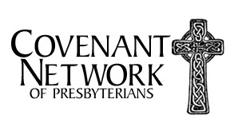
SATURDAY, MAY 27
9:15 AM A.A. meeting (closed) 10:30 AM A.A. meeting (open)

SUNDAY, MAY 28
10:00 AM Worship Service
10:15 AM Sunday’s Cool for grades PreK-7 11:15 AM Coffee Hour
11:15 AM Cherub Choir
11:30 AM Set up for Annual Memorial Day BBQ

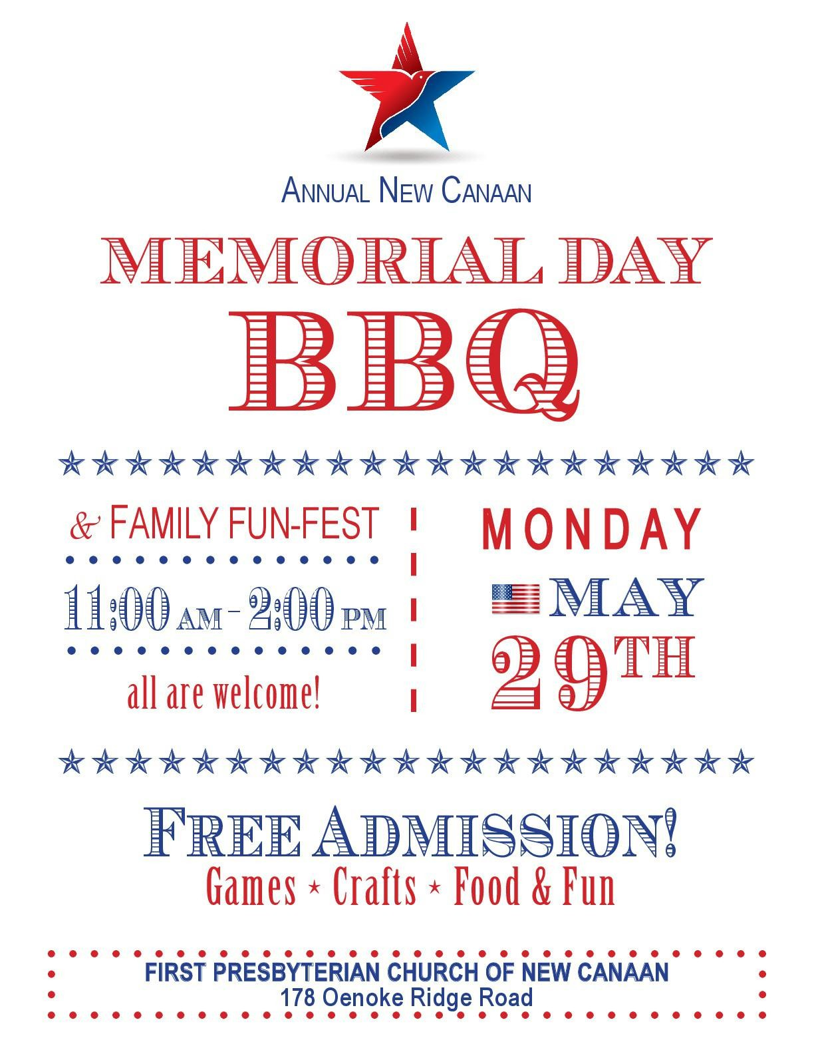

OUR MINISTERS
The Entire Congregation
OUR PASTORS
The Rev. Paul E. Gilmore, Pastor
The Rev. Kathryn Kibbie Laird, Associate Pastor for Children, Youth and Families
OUR STAFF
Victoria Shields, Director of Music / Sherry Tate, Cherub Choir director Michelle Olsen, Church Administrator / Tina St. Armand, Office Manager Erika Hagan, Administrative Assistant to Children and Youth Ministries
Kuky and Andres Pereira, Operations/Security Managers / Edgar Torres, Day Sexton
THE SESSION
Our Pastors
Scott Beyer, Clerk of Session
George Benington, Bell Tower Society
Sue Benko, Communications Katie Ferguson, Co-Youth Linda Ferguson, Nominating
Peter Flournoy, Worship, Music and Arts
Jennifer Gulden, Personnel John Lanaway, Stewardship Glenn Mierendorf, Outreach
Dede McEvoy, Strategy Planning
Andy Petitjean, Finance
Lynn Quinn, Adult Education
Julie Reeves, Membership Involvement
Jan Sulkowski, Youth Ministries Kevin Thomson, Advisory Committee Sarah Van de Graaf, Co-Youth
Jenny Volanakis, Children's Ministries Stephan von Jena, Buildings & Grounds Barbara Wentzel, Congregational Life
THE DEACONS
John Servidea, Moderator
Erica Bergmans, Inspirica Mary Jane Bolin, Senior Lunch Peg Bull, Flock Program Catherine Clark, Treasurer Emma Dahill, Co-Youth
Jack Dahill, Co-Youth
Cindy Hagopian, Inspirica
Karen Hanson, Memorial Services and Receptions
Beth Hersam, Flowers and Cards Chris Kniffin, Member-At-Large Linda Martin, Baptisms
Elizabeth Stuart, Flowers and Cards Sarah Robinson, Pastoral Care Team Kristen Rodgers, Member-At-Large Jen Van de Graaf, Secretary
Steve Van de Graaf, Member-At-Large
Patty von Jena, Meals-On-Wheels
Rev. T. Guthrie Speers, Jr., Pastor Emeritus - Mrs. Marilyn J. Ballantine, Minister of Music Emerita

