Easter Sunday
The Resurrection of the Lord
April 16, 2017

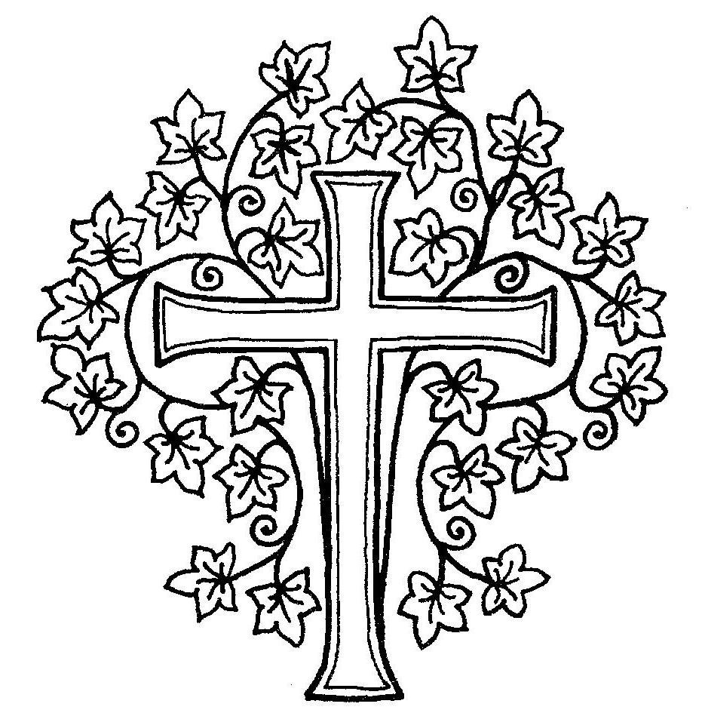

Alleluia!

GATHERING

*ALL WHO ARE ABLE ARE INVITED TO STAND

PRELUDE “Canzona Bergamasca” Samuel Scheidt
“Canzon Septimi Toni no. 2” Giovanni Gabrieli

*CALL TO WORSHIP Rev. Paul E. Gilmore
Minister: Alleluia! Christ is risen!
People: He is risen, indeed!
Minister: The trumpet sounds, eyes twinkle, the mystery deepens, all is changed.
People: Jesus Christ has broken the bonds of death! We are witnesses to the amazing good news.
Minister: God is creating a new day of joy. Turn from your weeping.
The tomb is empty. Death is not the last word.
People: Come and join the joyous dance of life.
Minister: For Christ is risen!
People: He is risen, indeed!

*HYMN No. 123 “Jesus Christ is Risen Today” Easter Hymn arr. Richard Webster

*EASTER AFFIRMATION (unison)
(9 a.m.) Rev. Christopher C. Tate (11 a.m.) Rev. Mary Marple Thies Minister: This is the Good News –
People: The grave is empty, Christ is risen!
Minister: This is the good news –
People: The light shines in the darkness and the darkness can never overcome it.
Minister: This is the good news –
People: Once we were no people, now we are God’s people.
Minister: This is the good news –
People: Christ is our peace, the indestructible peace we now share with each other.

*THE PEACE
Minister: The peace, hope, justice and joy of Christ, our risen Lord be with you.
People: And also with you.
Greet one another with words and signs of Christ’s reconciling peace.

WELCOME AND ANNOUNCEMENTS
Please sign the card and pass it to your neighbor. As you pass it back to the center, take note of who is here so we can become better acquainted. Visitors, please give your address, telephone, and e-mail information.

CHILDREN IN Pre-K-4TH GRADE ARE INVITED TO CHILDREN’S CHAPEL IN
THE COMMON ROOM. Older kids remain in the worship with their family.

THE WORD

PRAYER FOR ILLUMINATION (9 a.m.) Dede Bartlett (11 a.m.) Sherman Bull

Loving God, roll away the stone that covers our hearts. Through these words
which you give us, may we see your love made known, recognize the risen Lord
in our midst, and hear our names called by the One whose death and resurrection bring to us the gift of life abundant and life eternal. Amen.

FIRST LESSON Isaiah 25:6-9 (OT page 652)
Reader: Hear what the Spirit is saying to the church.
People: Thanks be to God.

ANTHEM
9:00 Anthem: “This is the Day” Natalie Sleeth Combined Cherub and Carol Choir
11:00 Anthem: “O Sons and Daughters” arr. John Ferguson
First Presbyterian Church and English Handbell Choir

SECOND LESSON Matthew 28:1-10 (NT pages 33-34)
Minister: Hear what the Spirit is saying to the church.
People: Thanks be to God.

SERMON “Trust the Catcher” Rev. Paul E. Gilmore

THE RESPONSE

*HYMN No. 118 “The Day of Resurrection” Lancashire arr. Dennis C. Klophaus

PRESENTATION OF TITHES, OFFERINGS AND OURSELVES

OFFERTORY “Antiphon” from Five Mystical Songs Ralph Vaughan Williams First Presbyterian Church Choir and Carol Choir

*DOXOLOGY WITH ALLELUIAS Lasst uns erfreuen

Praise God, from whom all blessings flow;
Praise God all creatures here below, Alleluia, Alleluia! Praise God above, ye heavenly host.
Creator, Christ and Holy Ghost, Alleluia, Alleluia, Alleluia, Alleluia, Alleluia!

INVITATION TO THE LORD’S TABLE

PRAYER OF GREAT THANKSGIVING
Minister: The Lord be with you.
People: And also with you. Minister: Lift up your hearts. People: We lift them to the Lord.
Minister: Let us give thanks to the Lord our God. People: It is right to give our thanks and praise. Minister: It is truly right and our greatest joy…

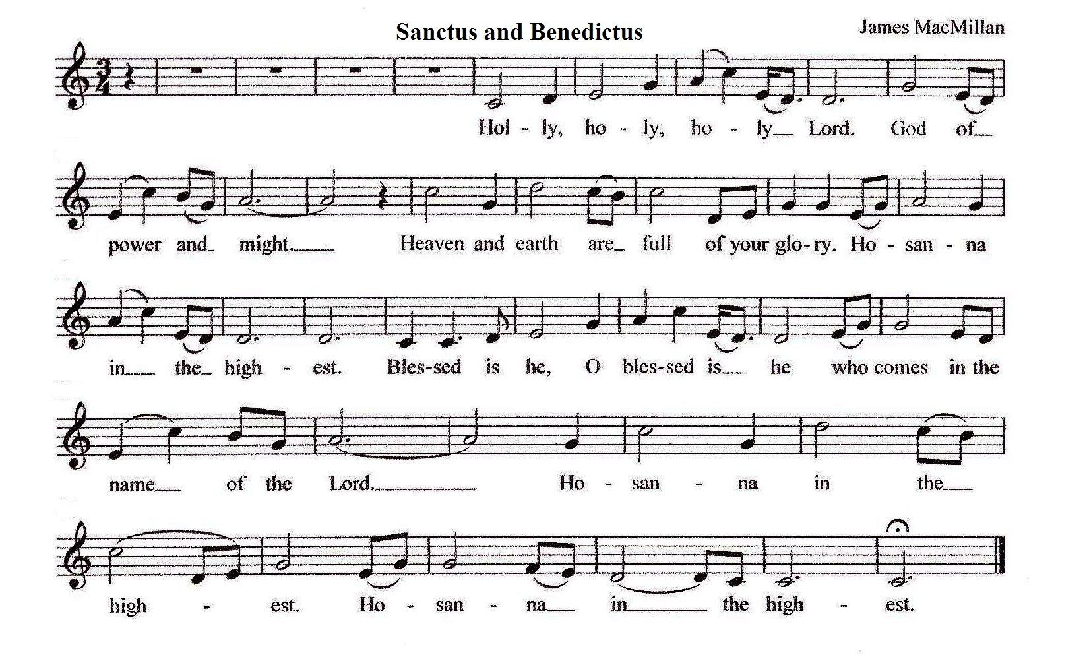
Please join in the responsive singing of the Sanctus and the singing of the Memorial Acclamation:

MEMORIAL ACCLAMATION Hymn No. 113 (verse 2) Llanfair

Love’s redeeming work is done, Alleluia! Fought the fight, the battle won; Alleluia! Death in vain forbids Him rise; Alleluia! Christ has opened paradise; Alleluia!
LORD'S PRAYER (unison)
Our Father who art in heaven, hallowed be thy name. Thy kingdom come, thy will be done, on earth as it is in heaven. Give us this day our daily bread; and forgive us our debts, as we forgive our debtors; and lead us not into temptation, but deliver us from evil. For thine is the kingdom and the power and the glory, forever. Amen.
WORDS OF INSTITUTION
*COMMUNION OF THE PEOPLE
Communion will be served by intinction in which the bread is dipped into the cup. The wine is served in two chalices: the larger chalice contains wine, the smaller, grape juice. Gluten- free crackers are available on each plate. “Thanks be to God,” is a proper response to the receiving of communion. We will begin with people in the back rows and work our way to the front.
COMMUNION MUSIC
9:00 Anthem: “Rejoice Greatly” Susan E. Geschke
Combined Chimes and Handbell Choir
11:00 Anthem: “Aria” Douglas E. Wagner English Handbell Choir
Congregational Hymn No. 106 “Alleluia, Alleluia! Give Thanks” Alleluia No.1 Please sing the refrain after every verse

PRAYER FOLLOWING COMMUNION
In the end as in the beginning, God is God: Loved by us, wanted by us, praised by us, served by us; filling folks with the gifts of the Spirit, making them whole for the good of the earth. For bread and wine, this place and this time, thanks be to God. For the peace we are promised which the world cannot destroy, thanks be to God. For the hope of heaven on earth and the final song of joy, thanks be to God. Amen.

SENDING
*HYMN No. 151 “Crown Him with Many Crowns” Diademata arr. Richard Webster

*CHARGE AND BLESSING
CHORAL RESPONSE “Awake, My Heart with Gladness” Johann Crüger First Presbyterian Choir and Brass Quintet

RINGING THE CHURCH BELL
*POSTLUDE “Grand Choeur Dialogué” Eugène Gigout
Brass Quintet and Organ arr. Gary Olson
TODAY AT FIRST PRESBYTERIAN
We welcome you to the Service of Worship for the Lord's Day. Parents of infants through 4 year olds are invited to take their children to the Nursery School classrooms during our services. 9 A.M. and 11:00 A.M.: Today in Sunday's Cool we will be combining grades PreK through 4th. Please follow your Rev. Kibbie to the Common Room for Children’s Chapel dedicated to the Easter Story.

TODAY’S WORSHIP PARTICIPANTS
Worship Coordinator: 9:00 A.M. Nancy Flournoy; 11:00 A.M. Dan McEvoy
Greeters: 9:00 A.M.: The Reeves family; 11:00 A.M.: The Gulden family; Ushers: 9:00 A.M.: Mavis Asare, Peter Bayer, Jim Beall, Hazel Hobbs; 11:00 A.M.: Brian Carlson, Peggy Hooker, Charlie Robinson, Sarah Robinson; Lay Readers: 9:00 A.M.: Dede Bartlett; 11:00 A.M.: Sherman Bull; Cross Bearers: 9:00 A.M.: Spencer Reeves; 11:00 A.M.: Peg Bull; Communion Preparers: 9:00 A.M.: Barbara Beall; 11:00 A.M.: Denise Riehl, Bev Thomas; Communion Officers: 9:00 A.M.: Emma Dahill, Linda Martin, Patty von Jena, Stephan von Jena; 11:00 A.M.: Jennifer Gulden, Dede McEvoy, Jen Van de Graaf, Sarah Van de Graaf.
Musicians: Both Services: The First Presbyterian Church Choir; English Handbell Choir; Brass Quintet (Matthew Anderson, trumpet, Carl Stanley, trumpet, Laura Weiner, horn, Burt Mason, trombone, Mark Broschinsky, trombone). At the 9 AM Service: Chimes Choir, Carol Choir, Cherub Choir, Sherry Tate, director, Christine Mangone, piano.
Sanctuary flower decorations provided by the Flower Committee.
Let us keep in our thoughts and prayers: Continued concerns: Grace Chung; Neil Coakley; Ann Depuy; Darren Dionne; Anne Blose Eydt (daughter of Marion Blose); Jennifer Gallagher (a member of the Riehl family); Graham Harden; Sister Therese Jacobs (friend of Mary Jane Bolin); Vince Lombardi; Doris Mierendorf; Beryl Stone (a friend of the Van de Graaf’s); The Stricos family (friends of Joe and Diana Ruszkowski); Ronald Witt. The Abo Noktah family (our Syrian refugees): Khaldoun (father), Khawla Alzob (mother), daughters Hanin (12) and Zain (5), and sons Yaman (11) and Ahmed, (10).
Flower Memorials: If you wish to have flowers in the sanctuary to celebrate an anniversary, a baptism, a birthday, or to memorialize a loved family member or friend please call Barbara Wentzel, Flower Coordinator, at 203-966-5402 or email at barbarawentzel@mac.com.

Calling all lads and lassies!! Scottish Sunday is April 30 With Scottish activities leading up to the big day
Sunday, April 23, 11:30am: Kiltmaker Bonnie Heather Greene will discuss the kiltmaking tr adition and provide tartan sample books for perusal to find you family tartan or pick one you like. In the Common Room.
Wednesday, April 26, 6:00pm: Assist master shortbread bakers Molly Ludtke and Susan Gress in the FPCNC kitchen to bake batches of homemade shortbread to share on Scottish Sunday. RSVP: cmbarbour@gmail.com
Friday, April 28, 6:00-8:00pm: Scottish Heritage Cocktail Party and Kirkin’ (get measured and order a custom kilt) at the home of Scott and Susan Gress. Bring an app and beverage to share. RSVP: cmbarbour@gmail.com
Sunday, April 30: (drop off lunch items in Common Room before going to the sanctuary) Join the fanfare starting with a bagpipe procession at the beginning of the 10:00 service, grab some coffee and homemade shortbread in the back of the sanctuary and enjoy the Ceilidh featuring Scottish songs, harp and bagpipes. Follow the pipers to the Common Room for lunch immediately following the Ceilidh and try some haggis (or not), bring something to share (plenty of non-haggis options) based on the first letter of your last name: A-E bring cold cuts; F-J bring sliced bread and cheese; K-N bring salads (green, pasta, cole slaw, potato salad); O-R bring fruit or dessert; S-V bring appetizers; W-Z bring condiments (mayo, mustard, pickles). The FPCNC Scottish Committee will provide wine, Scottish beer and soft drinks. A wee donation is much appreciated to defray our costs (we must pay the piper after all). Monies leftover will be donated to the Deacons Fund. RSVP: cmbarbour@gmail.com

THIS WEEK AT FIRST PRESBYTERIAN CHURCH
178 Oenoke Ridge, New Canaan, CT 06840 Tel.: 203-966-0002 / www.fpcnc.org
Church Office Hours are Monday-Friday 8:30 AM to 4:30 PM

SUNDAY, APRIL 16 Easter Sunday 9:00 AM Holy Communion Service
Presbyterian Choir School Spring Musical!

Sunday, June 4th at the 10am service!
On April 5th, we began rehearsals for the spring musical "In the Image." The musical features all ages, singers and non-singers who tell the story of God's creation in a Sunday School classroom. Thinking their teacher won the lottery and moved to Tahiti, the class takes over as teachers and discover that God really is the creator of all things - even snakes, mosquitos and Brussels sprouts! This fun, funny and uplifting musical is sure to be a hit!
Rehearsals will resume on Wednesday, April 19 from 5:00-6:30. The musical will be on Sunday, June 4th. Email Chris Tate at tatecg@yahoo.com or Victoria Shields at victoria@fpcnc.org for more information. We hope you'll join us!
Children's Chapel
10:15 AM Coffee Hour
11:00 AM Holy Communion Service
Children's Chapel
12:15 PM Coffee Hour
MONDAY, APRIL 17 Church Offices closed
2:00 PM Meditation Group
TUESDAY, APRIL 18
9:30 AM Leadership Team 11:30 AM Gentlemen Songsters 8:00 PM Men’s A.A.
WEDNESDAY, APRIL 19
9:30 AM Music Librarians 10:00 AM Dorcas Sewing Group 10:30 AM Pastoral Care Team 5:00 PM Cherub Choir
5:00 PM Spring Musical Rehearsal 5:00 PM Confirmation Class
THURSDAY, APRIL 20
3:30 PM Special Church 7:00 PM CaTS Team
7:30 PM FPC Choir
SATURDAY, APRIL 22
9:15 AM A.A. (closed)
10:30 AM A.A. (open)
SUNDAY, APRIL 23
10:00 AM “Holy Humor” Sunday
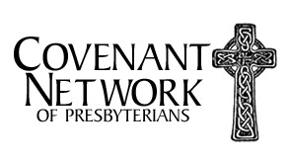
Rev. Paul E. Gilmore preaching 10:15 AM Church School for grades K-7 11:00 AM HSYG-Mission Trip Presentation 11:15 AM Coffee Hour
11:15 AM Cherub Choir
11:15 AM Membership Involvement Committee 11:30 AM Board of Deacons
11:30 AM Scottish Kilt/Tartan presentation 4:00 PM MSYG-Mission Trip Presentation 6:00 PM HSYG-Barn Time

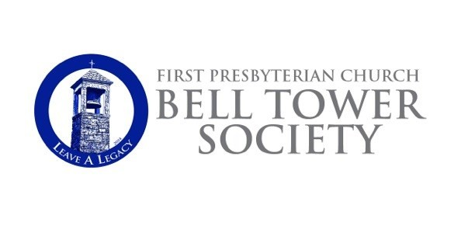If you have remembered FPCNC in your estate plans, and would like to be included on the list of members of the Bell Tower Society, please let Michelle Olsen in the church office know. Thank you for making plans to leave a legacy.

Easter Flowers
†In loving memory of Mr. and Mrs. George J. Thompson, and Mr. and Mrs. J. Perry Bartlett,
from Dede and Jim Bartlett.
†In loving memory of Leroy and Bonnie Pipkins Beyer, and George A. Baker, from Scott, Allison, Gray and Rachel Beyer.
†In loving memory of Stephen and Madeline Benko and Donald and Pearleen Baer, from the Benko family.
†In loving memory of Howard Blose, from his family.
†In loving memory of Frank Bondor, Steve Begala, and Dorothy Morse, from Anna Mae Bondor and family.
†In loving memory of Jim Bridgman, from his family.
†In loving memory of Bob Brownley, from his family.
†In loving memory of family and friends, from Sherman and Peg Bull.
†In loving memory of her mother, Joan DeGarmo, from Joan Caird and family.
†In loving memory of Sally Elbert Kalin, from her family.
†In loving memory of David Findlay Jr., from his family.
†In loving memory of Allison Foster Hartshorne, from Joanna Hartshorne, and Ted and Elaine Foster.
†For our dear grandparents who have already received the gift of eternal life, lovingly the Gifford Family.
†In loving memory of their parents, Carl and Frieda Nolte, and Jim and Bunny Otto,
and nephew, Cade James Griffin, from Len and Cindy Graziano.
†In loving memory of Isaac Hampel, from his family.
†In loving memory of Alan Wentzel, Charlie and Leonetta Gulden, Walter & Hazel Hanson,
from the Gulden/Wentzel family.
†In loving memory of Mom and Dad, from Karen Hanson.
†In loving memory of Bill Hart, from his Swan-Hart family.
†In loving memory of Gordon & Marilyn Jones, from the Holden/Jones family.
†In loving memory of George Hooker, from his family.
†In loving memory of her husband, Skip Kniffin, and his cousin, Mary Long, from Anne Kniffin and family.
†In loving memory of their parents, Rev. Louis E. Young and Jean Young, Greta Laird and James Laird,
and Ruth’s sister, Pat Larson, from the Laird family.
†In loving memory of their parents, Louis and Helen Dahle, and James and Julia Riehl,
and for the life of David M. Kispert and Dominique Schieck, from Denise and Jim Riehl.
†In loving memory of our parents, James S. Russell and Reginald and Noreen Martin,
from Linda and Paul Martin.
†In loving memory of Donal C. O’Brien, Jr., Constance and Donal O’Brien, and Nancy and George Slight,
and George Slight, Jr., from their family.
†In loving memory of Linda Moore Post, George Browne Post, Jr. and Irene Emery Goodale, from their family.
†In loving memory of Mary Ann Marston Jackson and Jack and Pat Quinn from the Quinn family.
†In honor of J. Tracey Mackle, and in loving memory of Maxine Mackle, with love from Vivi, Kate, Spencer, Julie and Michael Reeves.
†In loving memory of Bonnie’s grandparents, Thomas M. and Mary W. Curran, and John Irving, Mary Kennedy,
and Phillip Du Val, with love from Matt, Bonnie and Courtney Rumilly.
†In loving memory of her husband, Peter Schurman, and her brother, Donald Calhoun, from Judy Schurman.
†In loving memory of Tatjana Freelove, from the Servidea family.
†In loving memory of Jackson Johnson Taylor and Mary Ellen Trimmer Taylor, by their daughter Ellen Trimmer Taylor Sisson, Jack, Mary and Frances.
†In loving memory of our parents, from Nell and Roger Smith.
†In loving memory of George Stevens, from his family.
†In loving memory of Ned Swanberg, from his family.
†In loving memory of Craig Tate, William and Hazel Graham, and John and Evelyn Tate, from Sherry Tate.
†In loving memory of his mother, Eleanor Thies, and her parents, Margret and William Marple,
from Armin and Rev. Mary Marple Thies.
†In loving memory of Annunziata (Nancy) Colella, Evelyn & Alfred Kastrup and Estella & Atenógenes Villarreal,
from the Villarreal/Colella family.
†In memory of Ronald Watkins from his loving family.
†In loving memory of Miriam Finerty, Ann McGuiness, and Robert Wingate, from the Wingate family.
†In loving memory of her husband and their father, Bob Witt, from his family.

Our Ministers
The Entire Congregation
Our Pastors
The Rev. Paul E. Gilmore, Pastor
The Rev. Kathryn Kibbie Laird, Associate Pastor for Children, Youth and Families
Our Staff
Victoria Shields, Director of Music / Sherry Tate, Cherub Choir director Michelle Olsen, Church Administrator / Tina St. Armand, Office Manager Erika Hagan, Administrative Assistant to Children and Youth Ministries
Kuky and Andres Pereira, Operations/Security Managers / Edgar Torres, Day Sexton
The Session
Our Pastors
Scott Beyer, Clerk of Session
George Benington, Bell Tower Society
Sue Benko, Communications Katie Ferguson, Co-Youth Linda Ferguson, Nominating
Peter Flournoy, Worship, Music and Arts
Jennifer Gulden, Personnel John Lanaway, Stewardship Glenn Mierendorf, Outreach
Dede McEvoy, Strategy Planning
Andy Petitjean, Finance
Lynn Quinn, Adult Education
Julie Reeves, Membership Involvement
Jan Sulkowski, Y outh Ministries Kevin Thomson, Advisory Committee Sarah Van de Graaf, Co-Youth
Jenny Volanakis, Children's Ministries Stephan von Jena, Buildings & Grounds Barbara Wentzel, Congregational Life
The Deacons
John Servidea, Moderator
Erica Bergmans, Inspirica Mary Jane Bolin, Senior Lunch Peg Bull, Flock Program Catherine Clark, Treasurer Emma Dahill, Co-Youth
Jack Dahill, Co-Youth
Cindy Hagopian, Inspirica
Karen Hanson, Memorial Services and Receptions
Beth Hersam, Flowers and Cards Chris Kniffin, Member-At-Large Linda Martin, Baptisms
Elizabeth Stuart, Flowers and Cards Sarah Robinson, Pastoral Care Team Kristen Rodgers, Member-At-Large Jen Van de Graaf, Secretary
Steve Van de Graaf, Member-At-Large
Patty von Jena, Meals-On-Wheels
Rev. T. Guthrie Speers, Jr., Pastor Emeritus - Mrs. Marilyn J. Ballantine, Minister of Music Emerita

